**PSG COLLEGE OF TECHNOLOGY, COIMBATORE – 641 004**

**Department of Applied Mathematics and Computational Sciences**

**M Sc SOFTWARE SYSTEMS – Semester IV**

**20XW48 – Web Designing Lab**

**ROLL NO : 20PW39**

**PROBLEM SHEET 2 – HTML Tables, Image and Imagemap**

**Start Date: 3.1.2022 Complete Date: 13.1.2022**

1. Design a period table of the given form

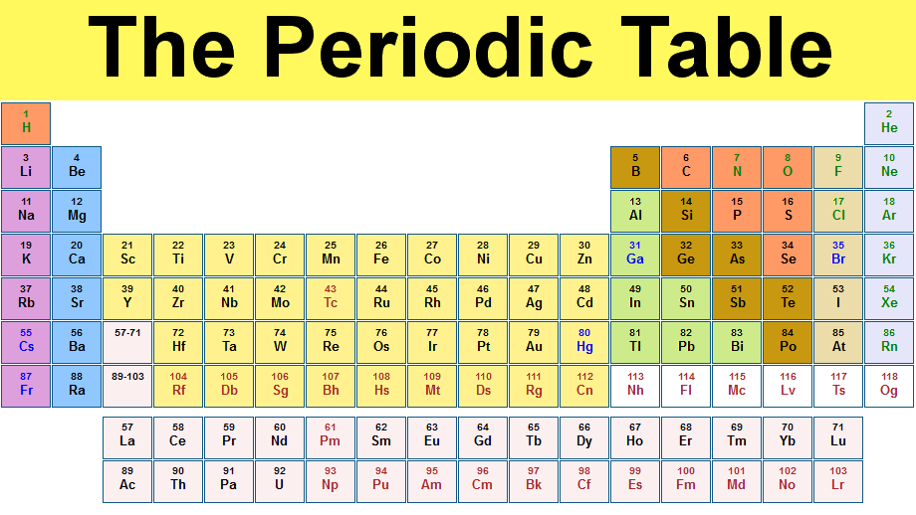

<html>

<head>

<title>Periodic Table

</title>

</head>

<body align="center">

<center>

<h1 style="background:yellow; padding:30">The Periodic Table</h1>

<table style="text-align:center;" border="2" width="1000">

<tr>

<td bgcolor="orange"><font color="green">1 </br></font><font color="green">H</font></td>

<td style="empty-cells:hide;" colspan="16"></td>

<td bgcolor="orange"><font color="green">2 </br></font><font color="green">He</font></td>

</tr>

<tr>

<td bgcolor="pink"><font color="black"></font>3<br/>Li</td>

<td bgcolor="lightblue"><font color="black"></font>4<br/>Be</td>

<td style="empty-cells:hide;" colspan="10"></td>

<td bgcolor="#B5651D"><font color="red"></font>5<br/>B</td>

<td bgcolor="orange"><font color="black">6<br/>C</td>

<td bgcolor="orange"><font color="green">7<br/>N</td>

<td bgcolor="orange"><font color="green">8<br/>O</td>

<td bgcolor="lightyellow"><font color="green">8<br/>F</td>

<td bgcolor="white"><font color="green">10<br/>Ne</td>

</tr>

<tr>

<td bgcolor="pink"><font color="black"></font>11<br/>Na</td>

<td bgcolor="lightblue"><font color="black"></font>12<br/>Mg</td>

<td border="0" style="empty-cells:hide;" colspan="10"></td>

<td bgcolor="lightgreen"><font color="Black"></font>13<br/>Al</td>

<td bgcolor="#B5651D"><font color="red"></font>14<br/>Si</td>

<td bgcolor="orange"><font color="black">15<br/>P</td>

<td bgcolor="orange"><font color="green">16<br/>S</td>

<td bgcolor="lightyellow"><font color="green">17<br/>Cl</td>

<td bgcolor="white"><font color="green">18<br/>Ar</td>

</tr>

<tr>

<td bgcolor="pink"><font color="black"></font>19<br/>K</td>

<td bgcolor="lightblue"><font color="black"></font>20<br/>Ca</td>

<td bgcolor="#FFFF33"><font color="black">21<br/>Sc</td>

<td bgcolor="FFFF33"><font color="black">22<br/>Ti</td>

<td bgcolor="FFFF33"><font color="black">23<br/>V</td>

<td bgcolor="FFFF33"><font color="black"></font>24<br/>Cr</td>

<td bgcolor="FFFF33"><font color="black">25<br/>Mn</td>

<td bgcolor="FFFF33"><font color="black"></font>26<br/>Fe</td>

<td bgcolor="FFFF33"><font color="black"></font>27<br/>Co</td>

<td bgcolor="FFFF33"><font color="black"></font>28<br/>Ni</td>

<td bgcolor="FFFF33"><font color="black"></font>29<br/>Cu</td>

<td bgcolor="FFFF33"><font color="black"></font>30<br/>Zn</td>

<td bgcolor="lightgreen"><font color="blue">31<br/>Ga</td>

<td bgcolor="#B5651D"><font color="black">32<br/>Ge</td>

<td bgcolor="#B5651D"><font color="black">33<br/>As</td>

<td bgcolor="orange"><font color="black">34<br/>Se</td>

<td bgcolor="lightyellow"><font color="blue">35<br/>Br</td>

<td bgcolor="white"><font color="green">36<br/>Kr</td>

</tr>

<tr>

<td bgcolor="pink"><font color="black"></font>37<br/>Rb</td>

<td bgcolor="lightblue"><font color="black"></font>38<br/>Sr</td>

<td bgcolor="#FFFF33"><font color="black"></font>39<br/>Y</td>

<td bgcolor="#FFFF33"><font color="black"></font>40<br/>Zr</td>

<td bgcolor="#FFFF33"><font color="black"></font>41<br/>Nb</td>

<td bgcolor="#FFFF33"><font color="black"></font>42<br/>Mo</td>

<td bgcolor="#FFFF33"><font color="red">43<br/>Tc</td>

<td bgcolor="#FFFF33"><font color="black"></font>44<br/>Ru</td>

<td bgcolor="#FFFF33"><font color="black"></font>45<br/>Rh</td>

<td bgcolor="#FFFF33"><font color="black"></font>46<br/>Pd</td>

<td bgcolor="#FFFF33"><font color="black"></font>47<br/>Ag</td>

<td bgcolor="#FFFF33"><font color="black"></font>48<br/>Cd</td>

<td bgcolor="lightgreen"><font color="black"></font>49<br/>In</td>

<td bgcolor="lightgreen"><font color="black"></font>50<br/>Sn</td>

<td bgcolor="#B5651D"><font color="black">51<br/>Sb</td>

<td bgcolor="B5651D"><font color="black">52<br/>Te</td>

<td bgcolor="lightyellow"><font color="black"></font>53<br/>I</td>

<td bgcolor="white"><font color="green">54<br/>Xe</td>

</tr>

<tr>

<td bgcolor="pink"><font color="blue">55<br/>Cs</td>

<td bgcolor="lightblue"><font color="black">56<br/>Ba</td>

<td width="0" bgcolor="pink"><font color="green">57-71

<td bgcolor="#FFFF33"><font color="black"></font>72<br/>Hf</td>

<td bgcolor="#FFFF33"><font color="black"></font>73<br/>Ta</td>

<td bgcolor="#FFFF33"><font color="black"></font>74<br/>W</td>

<td bgcolor="#FFFF33"><font color="black"></font>75<br/>Re</td>

<td bgcolor="#FFFF33"><font color="black"></font>76<br/>Os</td>

<td bgcolor="#FFFF33"><font color="black"></font>77<br/>Ir</td>

<td bgcolor="#FFFF33"><font color="black"></font>78<br/>Pt</td>

<td bgcolor="#FFFF33"><font color="black"></font>79<br/>Au</td>

<td bgcolor="#FFFF33"><font color="blue">80<br/>Hg</td>

<td bgcolor="lightgreen"><font color="black">81<br/>Tl</td>

<td bgcolor="lightgreen"><font color="black">82<br/>Pb</td>

<td bgcolor="lightgreen"><font color="black">83<br/>Bi</td>

<td bgcolor="B5651D"><font color="black">84<br/>Po</td>

<td bgcolor="lightyellow"><font color="black">85<br/>At</td>

<td bgcolor="white"><font color="green">86<br/>Rn</td>

</tr>

<tr>

<td bgcolor="pink"><font color="blue">87</font></br></td>

<td bgcolor="lightblue"><font color="black">88<br/>Ra</td>

<td bgcolor="pink">89-103<br/></td>

<td bgcolor="#FFFF33"><font color="red">104<br/>Rf</td>

<td bgcolor="#FFFF33"><font color="red">105<br/>Db</td>

<td bgcolor="#FFFF33"><font color="red">106<br/>Sg</td>

<td bgcolor="#FFFF33"><font color="red">107<br/>Bh</td>

<td bgcolor="#FFFF33"><font color="red">108<br/>hs</td>

<td bgcolor="#FFFF33"><font color="red">109<br/>Mt</td>

<td bgcolor="#FFFF33"><font color="red">110<br/>Ds</td>

<td bgcolor="#FFFF33"><font color="red">111<br/>Rg</td>

<td bgcolor="#FFFF33"><font color="red">112<br/>Cn</td>

<td bgcolor="white"><font color="red">113<br/>Rf</td>

<td bgcolor="white"><font color="red">114<br/>Rf</td>

<td bgcolor="white"><font color="red">115<br/>Rf</td>

<td bgcolor="white"><font color="red">116<br/>Rf</td>

<td bgcolor="white"><font color="red">117<br/>Rf</td>

<td bgcolor="white"><font color="red">118<br/>Og</td>

</tr>

</table><center>

<br><br>

<table style="text-align:center;" border="1px" width="700" align="center">

<tr>

<td bgcolor="pink"><font color="black">57<br/>La</td>

<td bgcolor="pink"><font color="black">58<br/>Ce</td>

<td bgcolor="pink"><font color="black">59<br/>Pr</td>

<td bgcolor="pink"><font color="black">60<br/>Nd</td>

<td bgcolor="pink"><font color="red">61<br/>Pm</td>

<td bgcolor="pink"><font color="black">62<br/>Sm</td>

<td bgcolor="pink"><font color="black">63<br/>Eu</td>

<td bgcolor="pink"><font color="black">64<br/>Gd</td>

<td bgcolor="pink"><font color="black">65<br/>Tb</td>

<td bgcolor="pink"><font color="black">66<br/>Dy</td>

<td bgcolor="pink"><font color="black">67<br/>Ho</td>

<td bgcolor="pink"><font color="black">68<br/>Er</td>

<td bgcolor="pink"><font color="black">69<br/>Tm</td>

<td bgcolor="pink"><font color="black">70<br/>Yb</td>

<td bgcolor="pink"><font color="black">71<br/>Lu</td>

</tr>

<tr>

<td bgcolor="pink">89<br/>Ac</td>

<td bgcolor="pink"><font color="black">90<br/>Th</td>

<td bgcolor="pink"><font color="black">91<br/>Pa</td>

<td bgcolor="pink"><font color="black">92<br/>U</td>

<td bgcolor="pink"><font color="black">93<br/>Np</td>

<td bgcolor="pink"><font color="red">94<br/>Pu</td>

<td bgcolor="pink"><font color="red">95<br/>Am</td>

<td bgcolor="pink"><font color="red">96<br/>Cm</td>

<td bgcolor="pink"><font color="red">97<br/>Bk</td>

<td bgcolor="pink"><font color="red">98<br/>Cf</td>

<td bgcolor="pink"><font color="red">99<br/>Es</td>

<td bgcolor="pink"><font color="red">100<br/>Fm</td>

<td bgcolor="pink"><font color="red">101<br/>Md</td>

<td bgcolor="pink"><font color="red">102<br/>No</td>

<td bgcolor="pink"><font color="red">103<br/>Lr</td>

</tr>

</table>

</body>

</html>

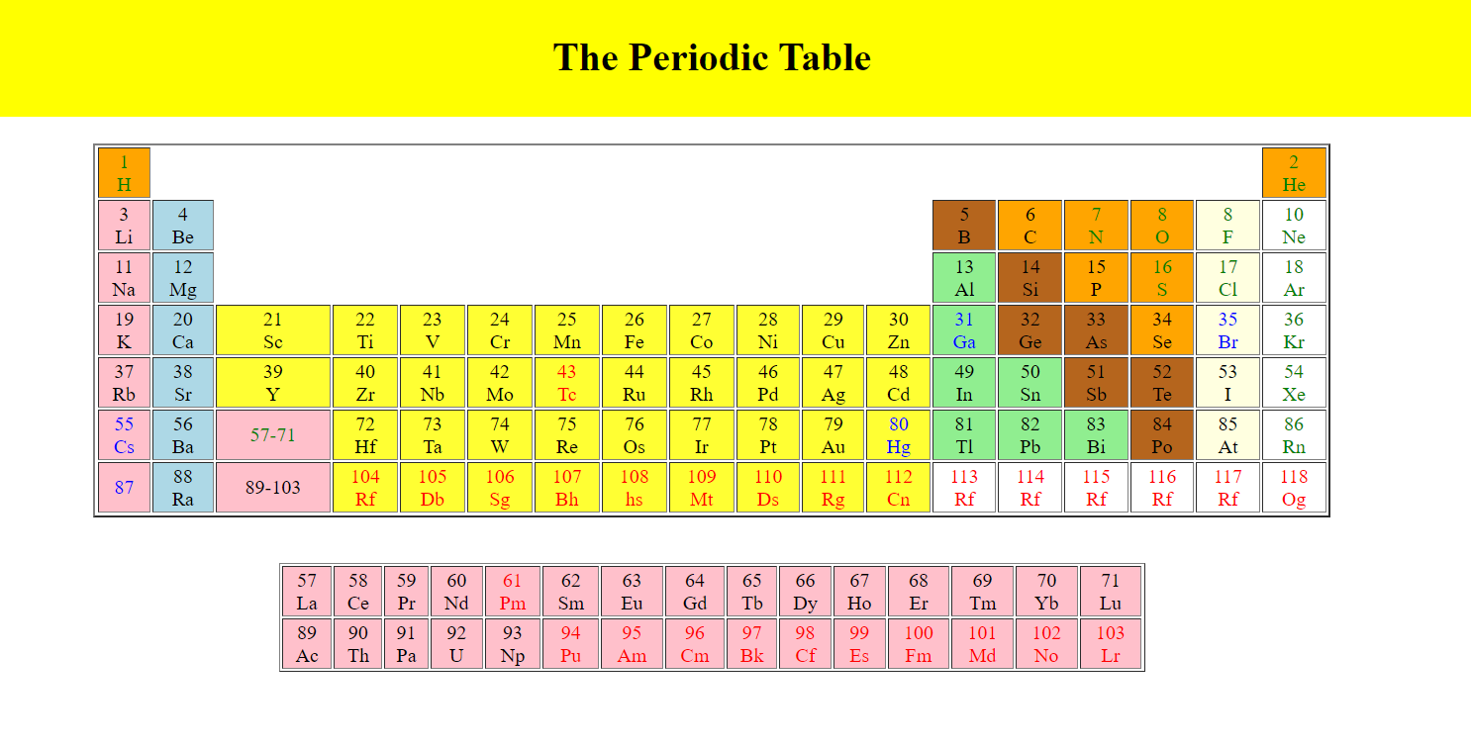

1. Design a table as given below. One image is align a left side and other image is in right sideas zigzap format. (Note: Instead of 1,2,3… you add any image and give description about an image)

(image type is animal/fruits/National leaders etc.,)



<!DOCTYPE html>

<html>

<head>

<style>

table,th,td

{

border:0px solid green;

}

table

{

width:30%;

background-color:#BCFDFD;

}

td

{

height:30px;

color:maroon;

font-weight:bold;

}

th

{

color:#B87333 ;

}

</style>

</head>

<body>

<table>

<tr>

<th>1</th>

<th>2</th>

<th>3</th>

</tr>

<tr>

<td><img src ="C:\Users\Dell\Downloads\msd.jpg" width="150" height="100"></td>

<td>M.S</td>

<td>DHONI</td>

</tr>

<tr>

<td><center>Aliya</center></td>

<td>Mustafina</td>

<td><img src="C:\Users\Dell\Downloads\aliya.jpg" width="150" height="100"></td>

</tr>

<tr>

<td><img src="C:\Users\Dell\Downloads\roger.jpg" height="120" width="150"></td>

<td><center>Roger</center></td>

<td>Federer</td>

</tr>

<tr>

<td><center>P.V.</center></td>

<td>Sindhu</td>

<td><img src="C:\Users\Dell\Downloads\sindhu.jpg" height="100" width="150"></td>

</tr>

</table>

</body>

</html>

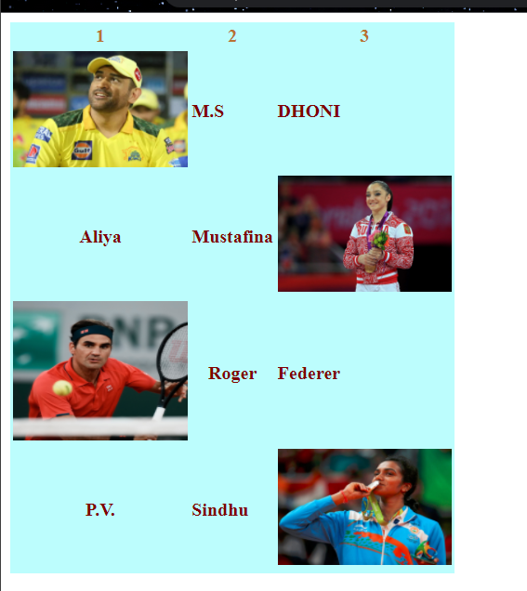

1. Design a table in the given way.

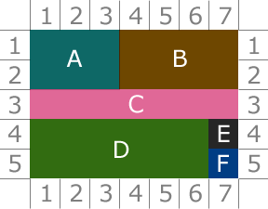

<html>

<body>

<style>

table,td,th

{

border-collapse: collapse;

border-color:2px blue;

}

}

</style>

<center>

<table style ="text-align:center;" border="2" style="border: width="550" height="350">

<div class="ex1">

<tr>

<td style="width:50px; height:50px;"></td>

<td style="width:50px; height:50px;"><font size="20" color="gray" face="Verdana">1</font></td>

<td style="width:50px; height:50px;"><font size="20" color="gray" face="Verdana">2</font></td>

<td style="width:50px; height:50px;"><font size="20" color="gray" face="Verdana">3</font></td>

<td style="width:50px; height:50px;"><font size="20" color="gray" face="Verdana">4</font></td>

<td style="width:50px; height:50px;"><font size="20" color="gray" face="Verdana">5</font></td>

<td style="width:50px; height:50px;"><font size="20" color="gray" face="Verdana">6</font></td>

<td style="width:50px; height:50px;"><font size="20" color="gray" face="Verdana">7</font></td>

<td style="width:50px; height:50px;"></td>

</tr>

<tr>

<td style="width:50px; height:50px;"><font size="20" color="gray" face="Verdana">1</font></td>

<td style="width:50px; height:50px;; border:none" bgcolor="turquoise" colspan="3" rowspan="2"><font size="20" color="white" face="Verdana">A</font></td>

<td style="width:50px; height:50px;; border:none" bgcolor="brown" colspan="4" rowspan="2"><font size="20" color="white" face="Verdana">B</font></td>

<td style="width:50px; height:50px;"><font size="20" color="gray" face="Verdana">1</font></td>

</tr>

<tr>

<td style="width:50px; height:50px;"><font size="20" color="gray" face="Verdana">2</font></td>

<td style="width:50px; height:50px;"><font size="20" color="gray" face="Verdana">2</font></td>

</tr>

<tr>

<td style="width:50px; height:50px;"><font size="20" color="gray" face="Verdana">3</font></td>

<td style="width:50px; height:50px;; border:none" bgcolor="violet" colspan="7"><font size="20" color="white" face="Verdana">C</font></td>

<td style="width:50px; height:50px;"><font size="20" color="gray" face="Verdana">3</font></td>

</tr>

<tr>

<td style="width:50px; height:50px;"><font size="20" color="gray" face="Verdana">4</font></td>

<td style="width:50px; height:50px;; border:none" bgcolor="green" colspan="6" rowspan="2"><font size="20" color="white" face="Verdana">D</font></td>

<td style="width:50px; height:50px;; border:none" bgcolor="black"><font size="20" color="white" face="Verdana">E</font></td>

<td style="width:50px; height:50px;"><font size="20" color="gray" face="Verdana">4</font></td>

</tr>

<tr>

<td style="width:50px; height:50px;"><font size="20" color="gray" face="Verdana">5</font></td>

<td style="width:50px; height:50px;; border:none" bgcolor="blue"><font size="20" color="white" face="Verdana">F</font></td>

<td style="width:50px; height:50px;"><font size="20" color="gray" face="Verdana">5</font></td>

</tr>

<tr>

<td style="width:50px; height:50px;"></td>

<td style="width:50px; height:50px;"><font size="20" color="gray" face="Verdana">1</font></td>

<td style="width:50px; height:50px;"><font size="20" color="gray" face="Verdana">2</font></td>

<td style="width:50px; height:50px;"><font size="20" color="gray" face="Verdana">3</font></td>

<td style="width:50px; height:50px;"><font size="20" color="gray" face="Verdana">4</font></td>

<td style="width:50px; height:50px;"><font size="20" color="gray" face="Verdana">5</font></td>

<td style="width:50px; height:50px;"><font size="20" color="gray" face="Verdana">6</font></td>

<td style="width:50px; height:50px;"><font size="20" color="gray" face="Verdana">7</font></td>

<td style="width:50px; height:50px;"></td>

</tr>

</div>

</table>

</body>

</html>

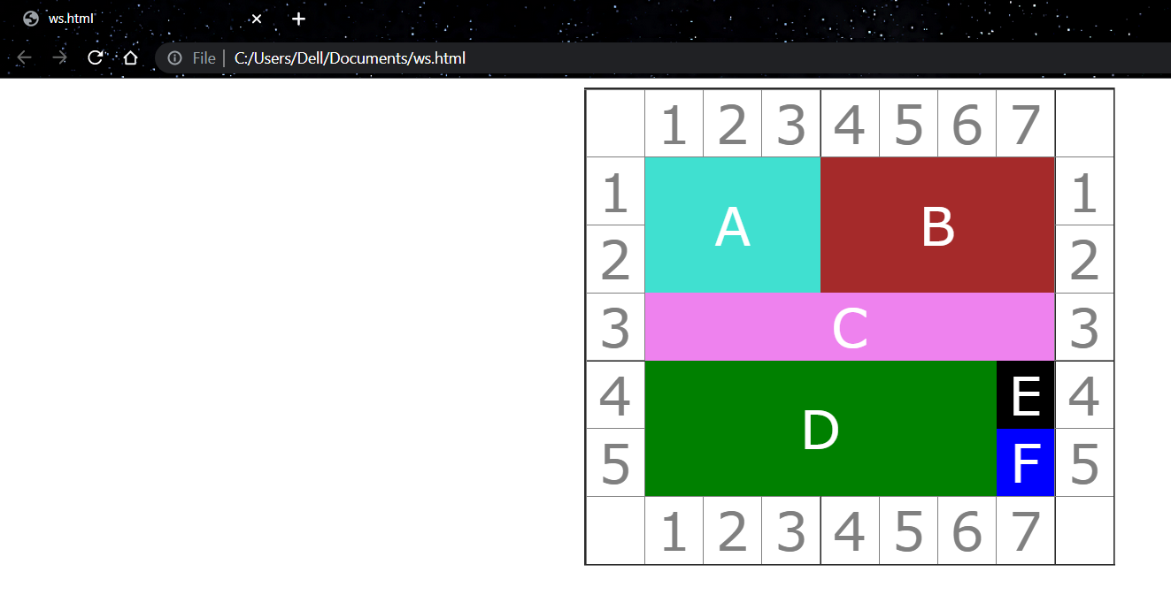

1. Design a table of ypur own with a background image. A sample is given for the reference.

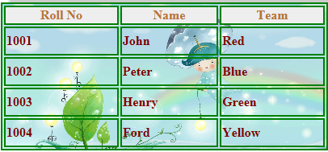

<!DOCTYPE html>

<html>

<head>

<style>

table,th,td

{

border:2px solid green;

}

table

{

width:30%;

background-image: url(C:\\Users\\Dell\\Downloads\\istockphoto-865067580-1024x1024.jpg);

}

td

{

height:30px;

color:maroon;

font-weight:bold;

}

th

{

background-color:#eee;

color:#B87333 ;

}

</style>

</head>

<body>

<table>

<tr>

<th>Roll No</th>

<th>Name</th>

<th>Team</th>

</tr>

<tr>

<td>1001</td>

<td>John</td>

<td>Red</td>

</tr>

<tr>

<td>1002</td>

<td>Peter</td>

<td>Blue</td>

</tr>

<tr>

<td>1003</td>

<td>Henry</td>

<td>Green</td>

</tr>

<tr>

<td>1004</td>

<td>Ford</td>

<td>Yellow</td>

</tr>

</table>

</body>

</html>

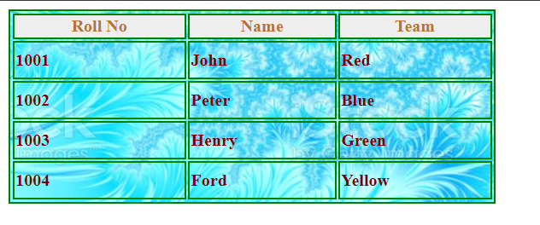

1. Design a page of the following design.

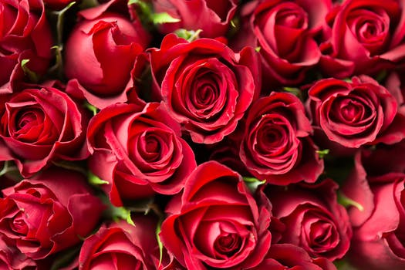

**Rose Flower** is a perennial plant the genus rosa, within the family roses. Roses are a popular crop for both domestic and commercial cut flowers. Generally they are harvested and cut when in bud, and held in refrigerated conditions until ready for display at their point of sale. In temperate climates, cut roses are often grown in greenhouses, and in warmer countries they may also be grown under cover in order to ensure that the **flowers** are not damaged by ~~weather~~ and that pests and disease control can be carried out effectively. There are many model project is on production of roses for use as cut flowers, which have an important place in *preparation* of bouquets, floral arrangements, worship, social occasions and presentation of gifts

<html>

<head>

</head>

<body>

<img align="middle" src="C:\\Users\\Dell\\Downloads\\rose.jpg" width="400" height="400" >

<p><b>Rose Flower</b> is a perennial plant the genus rosa, within the family roses. Roses are a popular crop for both <u>domestic and commercial</u> cut flowers. Generally they are harvested and cut when in bud, and held in refrigerated conditions until ready for display at their point of sale. In temperate climates, cut roses are often grown in greenhouses, and in warmer countries they may also be grown under cover in order to ensure that the <b>flowers</b> are not damaged by <strike>weather</strike> and that pests and disease control can be carried out effectively. There are many model project is on production of roses for use as cut flowers, which have an important place in preparation of bouquets, floral arrangements, worship, social occasions and presentation of gifts </p>

</body>

</html>

1. **Image and Text**

The red chilipepperchilipepper is a popular food product in New Mexico.  What creates the heat in this pepper is the chemical *capsaicin* (C18H27NO3).  When eaten, natural endorphins in the body are released which not only reduce the pain from the heat but create a feeling of general well-being.

<!DOCTYPE html>

<html>

<body>

The red chilipepper <img src="C:\\Users\\Dell\\Downloads\\red.jpg" height="18" width="20"> is a popular food product in New Mexico. What creates the heat in this pepper is the chemical capsaicin (C18H27NO3). When eaten, natural endorphins in the body are released which not only reduce the pain from the heat but create a feeling of general well-being.

</body>

</html>

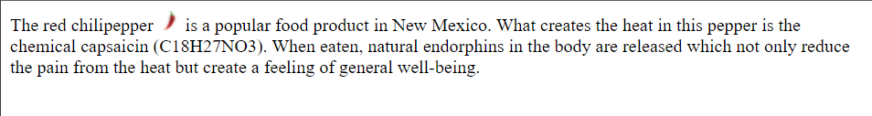

1. **Image and align text**

|  |  |
| --- | --- |
| **The Indian Flag** | |
| http://indianflag.facts.co/Indian_Flag_CC30_Pogaface.png | The National flag of India hasthreeequal horizontal bands - the top panel is India saffron (Kesari), the bottom panel is India green and white middle band bearing at its centre the design of Ashoka Chakra in navy blue colour with 24 equally spaced spokes. It was adopted by the Constituent Assembly on 22nd July 1947, when it became the official flag of the Dominion of India. The flag was subsequently retained as that of the Republic of India. The flag is based on the Swaraj flag, a flag of the Indian National Congress designed by PingaliVenkayya. |

<html>

<head>

</head>

<body>

<table border="1" cellpadding="20" cellspacing="0" width="600px" height="100px">

<tr>

<td colspan="7"><center><b>The Indian Flag</b></center></font></td>

</tr>

<tr>

<td colspan="3" width="200"><img src="C:\\Users\\Dell\\Downloads\\indian-flag-3607410__480.jpg" width="250" height="300"></td>

<td colspan="4" width="200"></font>The National flag of India hasthreeequal horizontal bands - the top panel is India saffron (Kesari), the bottom panel is India green and white middle band bearing at its centre the design of Ashoka Chakra in navy blue colour with 24 equally spaced spokes. It was adopted by the Constituent Assembly on 22nd July 1947, when it became the official flag of the Dominion of India. The flag was subsequently retained as that of the Republic of India. The flag is based on the Swaraj flag, a flag of the Indian National Congress designed by PingaliVenkayya</td>

</tr>

</table>

</body>

</html>

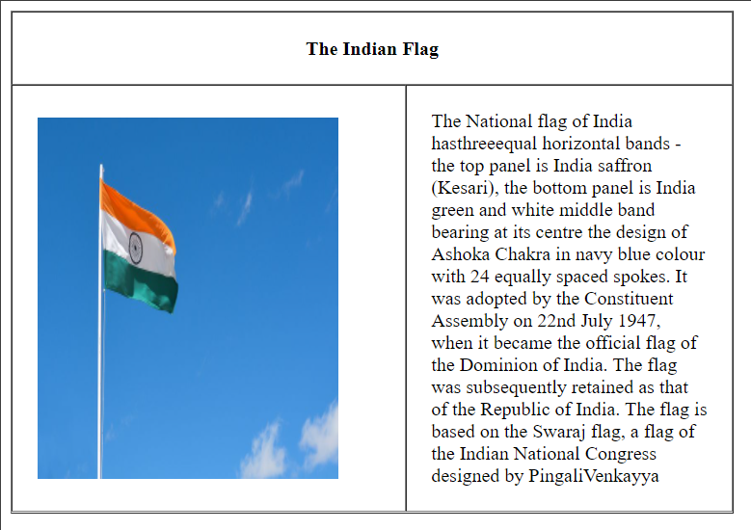

1. Create a Html page which depicts the lifecycle of a chicken as shown.

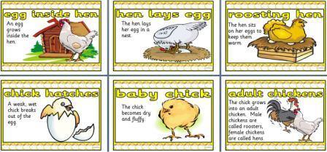

<!DOCTYPE html>

<html>

<style media="screen">

table {

margin: 0 auto;

border-collapse: collapse;

border-style: hidden;

/*Remove all the outside

borders of the existing table*/

}

table td {

padding: 0.5rem;

border: 2px solid grey;

}

table th {

padding: 0.5rem;

border: 2px solid grey;

}

</style>

</head>

<body>

<center>

<table border="1" cellspacing="3" cellpadding="3" rules="rows">

<tr>

<th><img src="C:\\Users\\Dell\\Downloads\\1.jpg" width="150" height="120" padding="2"></th>

<th><img src="C:\\Users\\Dell\\Downloads\\2.jpg" width="150" height="120" padding="2"></th>

<th><img src="C:\Users\Dell\Downloads\3.jpg" width="150" height="120" padding="2"></th>

</tr><tr>

<td><img src="C:\\Users\\Dell\\Downloads\\4.jpg" width="150" height="120" padding="2"></td>

<td><img src="C:\Users\Dell\Downloads\5.jpg" width="150" height="120" padding="2"></td>

<td><img src="C:\Users\Dell\Downloads\6.jpg" width="150" height="120" padding="2"></td>

</tr>

</table>

</center>

</body>

</html>

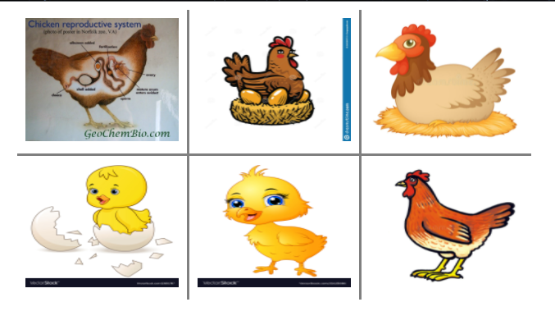

1. Create some links to various search engines (google, yahoo, etc).

[Search the web with Google!](http://www.google.com/)  
  
[Search the web with Yahoo!](http://www.yahoo.com/)  
  
[Search the web with Bing!](http://www.bing.com/)

<!DOCTYPE html>

<html>

<body>

<h1>HTML Links</h1>

<p><a href="https://www.google.com/?authuser=1"><u>Search the web with Google!</u></a></p>

<a href="https://in.search.yahoo.com/?fr2=inr"><u>Search the web with Yahoo!</u></a><br>

<a href="https://www.bing.com/"><u>Search the web with Bing!</u></a>

</body>

</html>



1. Display five different images. Skip two lines between each image. Each image should have a title.

<html>

<head>

<title>Five images</title>

</head>

<body>

<img src="C:\\Users\\Dell\\Downloads\\purple.jpg" alt="purple" height="200" width="400" title="purple" />

<br /><br />

<img src="C:\\Users\\Dell\\Downloads\\scenery.jpg" alt="Scenery" height="200" width="400" title="Scenery" />

<br /><br />

<img src="C:\\Users\\Dell\\Downloads\\eiffel.jpg"" alt="Eiffel" height="200" width="200" title="eiffel" />

<br /><br />

<img src="C:\\Users\\Dell\\Downloads\\bubbles.jpg" alt="bubble" height="200" width="200" title="bubble" />

<br /><br />

<img src="C:\\Users\\Dell\\Downloads\\20492873.jpg" src="random" height="200" width="200" title="random" />

</body>

</html>

1. Display an image that has a border of size 2, a width of 200, and a height of 200.

<html>

<body>

<img src="C:\\Users\\Dell\\Downloads\\purple.jpg" width="200" height="200" alt="Tree" border="2" />

</body>

</html>

1. Display an image that when clicked will link to a search engine of your choice (should be opened in a new window).

<html>

<body>

<a href="http://www.yahoo.com" target="_blank">

<img src="C:\\Users\\Dell\\Downloads\\eiffel.jpg" alt="Swan" />

</a>

</body>

<p>

Click on the image to be taken to the Yahoo search engine.

</p>

</html>

1. Create a webpage using image map tag. If click on any logo image, show the information about the company using unordered/ordered list tag. Minimum 5 information for each icon.



<!DOCTYPE html>

<html>

<table>

<!-- Image Map Generated by http://www.image-map.net/ -->

<img src="C:\Users\Dell\Downloads\logo.jpg" usemap="#image-map" >

<map name="image-map">

<area target="_blank" alt="pepsi" title="pepsi" href="https://en.wikipedia.org/wiki/Pepsi" coords="58,527,98,567,28,447,35,414,32,396,37,371,124,260,139,260,155,247,192,245,263,245,294,256,325,282,359,318,377,347,396,404,396,449,345,560,314,587,248,606,188,607,130,593,94,555" shape="poly">

<area target="_blank" alt="kfc" title="kfc" href="https://en.wikipedia.org/wiki/KFC" coords="749,238,770,238,787,238,874,274,900,296,914,318,951,391,940,485,922,533,902,551,867,576,840,582,812,602,763,609,676,595,634,558,609,522,589,478,574,407,598,342,629,294,690,243" shape="poly">

<area target="_blank" alt="bk" title="bk" href="https://en.wikipedia.org/wiki/Burger_King" coords="1398,238,1342,233,1295,238,1245,256,1213,278,1180,278,1180,320,1167,325,1156,362,1142,376,1131,402,1133,449,1156,493,1185,547,1215,573,1242,593,1273,595,1315,609,1360,618,1389,596,1431,578,1466,538,1500,493,1509,449,1515,420,1508,384,1508,333,1500,262" shape="poly">

<area target="_blank" alt="harvard" title="harvard" href="https://en.wikipedia.org/wiki/Harvard_University" coords="1815,223,1791,228,1770,248,1735,254,1702,294,1679,294,1642,328,1642,357,1637,421,1648,459,1651,483,1666,559,1700,565,1739,590,1768,608,1808,625,1839,625,1930,614,1957,596,1986,536,2015,514,2030,436,2023,365,2001,305,1984,254,1942,215,1895,217" shape="poly">

<area target="_blank" alt="nasa" title="nasa" href="https://www.nasa.gov/audience/forstudents/5-8/features/symbols-of-nasa.html" coords="199,737,232,733,270,729,299,726,365,720,481,664,612,735,725,675,794,915,698,917,587,911,412,931,305,931,192,888" shape="poly">

<area target="_blank" alt="apple" title="apple" href="https://en.wikipedia.org/wiki/Apple_Inc." coords="894,640,976,624,1082,602,1149,636,1184,680,1216,731,1211,775,1215,849,1244,904,1222,966,1207,995,1129,1017,1003,1048,898,1008,843,842" shape="poly">

<area target="_blank" alt="ggl" title="ggl" href="https://en.wikipedia.org/wiki/Google" coords="1346,711,1518,682,1644,711,1864,704,1888,747,1941,815,1926,871,1750,958,1673,948,1571,917,1480,935,1420,920,1376,922,1344,909,1309,833" shape="poly">

</map>

</table>

</body>

</html>

1. Design an image map for the given images. Info about indian states should be displayed when hover/clicked.

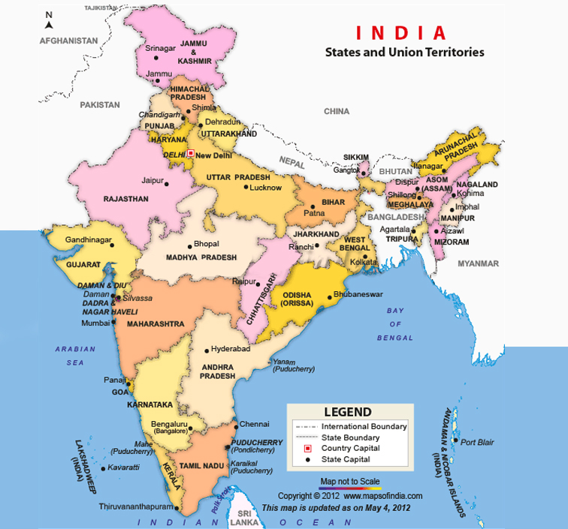

<html>

<body>

<img src="ind.jpg" usemap="#image-map">

<map name="image-map">

<area target="_blank" alt="" title="" href="<https://en.wikipedia.org/wiki/Jammu_and_Kashmir_(union_territory)>" coords="180,67,194,51,168,28,220,6,261,41,296,33,316,40,309,64,289,81,288,93,296,95,300,108,290,117,277,108,271,112,263,103,256,107,245,98,228,105,228,111,217,118,204,115,206,106,184,100" shape="poly">

<area target="_blank" alt="" title="" href="<https://en.wikipedia.org/wiki/Himachal_Pradesh>" coords="221,123,227,115,227,104,243,97,254,106,263,102,271,113,279,120,283,126,286,145,271,144,263,150,263,162,250,162,246,152,239,149,237,140,231,142,226,127" shape="poly">

<area target="_blank" alt="" title="" href="<https://en.wikipedia.org/wiki/Punjab,_India>" coords="215,120,203,127,199,135,200,141,199,147,192,151,186,159,185,170,197,172,207,175,210,182,217,176,229,180,231,170,237,172,243,164,244,154,237,149,236,138,230,142,227,133,225,127,219,122" shape="poly">

<area target="_blank" alt="" title="" href="<https://en.wikipedia.org/wiki/Uttarakhand>" coords="289,140,285,144,271,142,262,148,263,161,257,164,267,167,262,177,267,183,275,180,278,184,285,187,281,192,287,194,293,198,309,201,326,169,303,150,294,146" shape="poly">

<area target="_blank" alt="" title="" href="<https://en.wikipedia.org/wiki/Haryana>" coords="244,155,243,163,235,171,228,178,216,175,210,182,204,173,195,177,197,185,209,189,215,199,225,214,223,223,231,216,236,221,242,215,243,227,251,224,257,212,247,209,250,197,247,185,259,165,250,162" shape="poly">

<area target="_blank" alt="" title="" href="<https://en.wikipedia.org/wiki/Uttar_Pradesh>" coords="264,166,257,163,247,184,249,197,247,206,256,210,256,220,251,226,257,237,255,247,267,246,283,248,289,258,282,274,275,278,273,286,270,296,273,304,281,308,285,306,281,295,278,282,285,280,293,287,304,286,314,282,313,290,328,286,325,292,333,292,339,287,355,297,364,298,365,312,373,317,379,312,382,300,378,288,389,280,393,272,402,273,393,262,395,250,389,238,378,232,366,231,357,225,345,223,335,214,322,208,309,202,292,196,280,191,283,186,277,182,267,182,261,176" shape="poly">

<area target="_blank" alt="" title="" href="<https://en.wikipedia.org/wiki/Bihar>" coords="387,235,402,236,416,247,425,244,428,250,435,250,458,254,478,251,472,262,477,273,471,278,458,287,457,296,445,297,443,302,435,294,427,297,414,302,408,300,404,305,393,299,382,300,377,288,388,280,391,272,402,272,392,261,395,248" shape="poly">

<area target="_blank" alt="" title="" href="<https://en.wikipedia.org/wiki/Sikkim>" coords="473,235,474,218,489,212,492,218,490,226,490,234,481,236" shape="poly">

<area target="_blank" alt="" title="" href="<https://en.wikipedia.org/wiki/West_Bengal>" coords="489,234,483,236,472,233,478,249,473,258,475,271,471,276,474,297,461,313,444,322,436,322,434,327,448,334,447,340,454,343,457,353,470,363,485,352,483,359,489,359,496,354,502,357,500,325,489,315,493,308,491,300,480,293,494,278,479,267,483,251,490,256,496,251,503,258,508,254,513,245,500,241" shape="poly">

<area target="_blank" alt="" title="" href="<https://en.wikipedia.org/wiki/Assam>" coords="514,243,523,239,536,240,572,231,590,231,603,216,635,203,635,213,639,218,588,264,591,269,584,292,577,290,572,300,567,290,574,272,568,260,554,254,550,260,519,260,515,267,510,255,513,249" shape="poly">

<area target="_blank" alt="" title="" href="<https://en.wikipedia.org/wiki/Arunachal_Pradesh>" coords="558,231,557,224,545,218,549,212,554,216,558,211,568,213,568,204,576,199,579,192,593,189,606,172,625,178,636,166,640,172,638,178,645,174,645,181,641,190,651,189,661,191,664,199,657,208,661,217,646,216,629,233,622,231,639,215,634,201,602,214,590,229,572,230" shape="poly">

<area target="_blank" alt="" title="" href="<https://en.wikipedia.org/wiki/Meghalaya>" coords="515,266,519,259,549,259,555,252,566,259,574,271,571,277,559,273,553,277,542,273,534,276,525,280,515,275" shape="poly">

<area target="_blank" alt="" title="" href="<https://en.wikipedia.org/wiki/Tripura>" coords="566,290,551,302,545,318,555,330,561,324,562,310,570,310,572,299" shape="poly">

<area target="_blank" alt="" title="" href="<https://en.wikipedia.org/wiki/Mizoram>" coords="592,301,584,299,584,290,575,289,572,300,571,310,574,319,573,326,579,344,591,344,588,326,594,321,594,308" shape="poly">

<area target="_blank" alt="" title="" href="<https://en.wikipedia.org/wiki/Manipur>" coords="592,299,584,298,584,290,590,270,595,272,597,263,606,265,612,261,617,265,613,270,621,275,614,281,610,302" shape="poly">

<area target="_blank" alt="" title="" href="<https://en.wikipedia.org/wiki/Nagaland>" coords="629,232,622,232,588,262,593,270,597,263,606,263,612,259,616,265,622,259,622,252,627,245,622,238" shape="poly">

<area target="_blank" alt="" title="" href="<https://en.wikipedia.org/wiki/Jharkhand>" coords="470,278,457,285,456,295,445,296,442,301,435,294,412,299,404,305,394,299,383,299,379,310,389,320,395,320,394,329,401,336,394,348,399,350,405,349,417,347,416,354,428,354,435,357,437,346,455,352,453,342,447,339,448,332,434,327,436,322,445,320,461,314,472,295" shape="poly">

<area target="_blank" alt="" title="" href="<https://en.wikipedia.org/wiki/Rajasthan>" coords="185,172,176,175,167,193,153,200,141,219,121,224,113,213,94,231,91,243,105,247,104,261,106,269,114,269,113,278,122,293,129,295,142,295,147,301,158,303,164,301,161,307,168,309,169,321,187,332,195,330,194,322,200,321,197,294,207,290,207,296,213,298,219,296,222,301,217,311,214,318,222,315,227,308,242,310,239,300,244,303,240,293,252,285,247,279,240,284,233,276,235,268,242,268,247,262,270,247,260,247,255,250,259,241,252,233,252,225,245,228,244,215,236,221,232,213,229,226,226,217,216,208,217,198,211,190,204,187,197,188,198,179,198,175" shape="poly">

<area target="_blank" alt="" title="" href="<https://en.wikipedia.org/wiki/Gujarat>" coords="122,293,142,294,146,299,158,302,163,298,160,307,167,308,169,319,186,331,189,337,187,344,180,344,180,358,174,362,175,369,181,368,172,376,176,384,170,391,163,384,164,396,156,400,152,392,155,384,154,377,147,375,154,365,147,350,155,349,142,349,138,358,141,364,136,374,112,383,98,378,80,358,72,344,77,345,94,342,110,326,102,325,93,331,79,333,71,327,62,319,60,305,70,306,70,298,78,301,86,298,94,304,101,297,108,298,112,302,120,298" shape="poly">

<area target="_blank" alt="" title="" href="<https://en.wikipedia.org/wiki/Maharashtra>" coords="155,404,167,395,174,395,175,377,183,375,186,369,195,371,205,380,214,382,229,387,252,375,260,373,272,375,282,379,296,382,303,385,308,380,313,385,314,395,315,408,318,421,312,421,266,419,262,425,257,429,252,437,248,445,231,447,229,453,230,461,224,466,217,470,203,476,186,484,166,505" shape="poly">

<area target="_blank" alt="" title="" href="<https://en.wikipedia.org/wiki/Odisha>" coords="343,448,354,435,360,416,359,409,361,395,370,380,376,379,385,365,395,352,410,345,422,351,432,356,446,350,460,361,458,368,456,384,452,393,446,400,439,410" shape="poly">

<area target="_blank" alt="" title="" href="<https://en.wikipedia.org/wiki/Chhattisgarh>" coords="316,435,320,424,335,422,327,414,322,403,320,395,322,379,322,366,334,361,344,346,363,334,355,322,378,316,387,322,390,334,394,341,388,358,383,366,364,380,362,386,358,400,356,409,355,416,350,432,344,441,336,459" shape="poly">

<area target="_blank" alt="" title="" href="<https://en.wikipedia.org/wiki/Madhya_Pradesh>" coords="182,356,185,348,192,342,193,330,202,318,204,302,218,312,234,312,241,310,253,289,251,280,244,276,256,269,272,258,285,257,288,265,285,272,272,286,270,299,283,306,288,287,301,295,307,290,318,290,342,295,349,298,366,310,367,317,356,318,346,332,346,341,340,344,334,346,326,355,320,363,309,367,296,368,276,368,260,368,242,365,229,373" shape="poly">

<area target="_blank" alt="tn" title="tn" href="<https://en.wikipedia.org/wiki/Tamil_Nadu>" coords="223,602,237,599,252,594,251,584,253,577,259,572,266,574,274,572,283,569,293,565,301,564,313,560,316,566,311,576,306,591,303,607,305,620,296,635,303,631,287,647,229,612,234,624,240,633,243,643,244,652,241,669,241,681,252,684,264,674,260,678,269,665,279,660,283,652" shape="poly">

<area target="_blank" alt="kr" title="kr" href="<https://en.wikipedia.org/wiki/Kerala>" coords="192,576,201,583,207,589,219,596,225,603,226,611,233,621,235,628,235,637,243,634,243,641,243,656,242,667,238,679,231,668,224,653,222,638,213,623,209,609,204,598,194,583,227,661" shape="poly">

<area target="_blank" alt="kn" title="kn" href="<https://en.wikipedia.org/wiki/Karnataka>" coords="177,523,177,516,177,505,181,495,181,488,190,482,194,477,206,476,213,466,227,467,234,456,242,447,250,448,253,454,254,462,250,472,250,481,249,490,250,496,242,502,240,512,240,519,235,525,234,531,234,540,243,539,248,548,259,549,264,553,273,563,270,570,262,575,254,574,252,580,252,588,240,599,232,599,250,596,221,597,212,593,205,588,196,578,192,564,192,570,188,552,179,530,183,538,188,544" shape="poly">

<area target="_blank" alt="ap" title="ap" href="<https://en.wikipedia.org/wiki/Andhrapradesh>" coords="259,438,262,421,272,414,286,414,306,417,314,435,322,446,331,455,357,454,340,456,351,453,363,445,373,443,385,430,395,432,402,434,394,447,400,440,388,452,371,465,381,460,360,477,357,486,342,489,348,487,331,508,336,497,316,506,326,502,311,514,309,527,311,542,312,555,287,564,302,564,278,571,271,574,263,547,247,546,238,530,245,502,255,489,249,471,254,455,256,446,250,459,253,478,248,495,241,508,239,522,241,541,255,547,270,560,295,563,253,465,242,517,272,567" shape="poly">

<area target="_blank" alt="goa" title="goa" href="<https://en.wikipedia.org/wiki/Goa>" coords="165,501,172,505,179,513,174,523,167,516,165,511" shape="poly">

</map>

</body>

</html>

1. Design an image map for the given picture and when clicked/moved over, info about that person should be displayed.

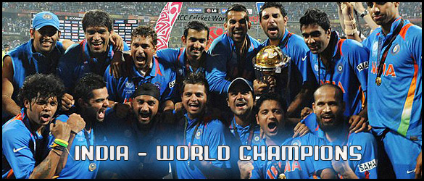

<html>

<body>

<img src="1.jpg" width="600px" height="300px" usemap="#players">

<map name="players">

<area shape="rect" coords="45 19 82 71" href="<https://en.wikipedia.org/wiki/MS_Dhoni>">

<area shape="rect" coords="114 14 167 67" href="<https://en.wikipedia.org/wiki/Munaf_Patel>">

<area shape="rect" coords="173 35 233 106" href="<https://en.wikipedia.org/wiki/Sachin_Tendulkar>">

<area shape="rect" coords="239 24 302 88" href="<https://en.wikipedia.org/wiki/Gautam_Gambhir>">

<area shape="rect" coords="302 4 353 75" href="<https://en.wikipedia.org/wiki/Zaheer_Khan>">

<area shape="rect" coords="351 7 413 64" href="<https://en.wikipedia.org/wiki/Yuvraj_Singh>">

<area shape="rect" coords="416 7 470 94" href="<https://en.wikipedia.org/wiki/Ravichandran_Ashwin>">

<area shape="rect" coords="493 1 568 66" href="<https://en.wikipedia.org/wiki/Ashish_Nehra>">

<area shape="rect" coords="25 95 101 171" href="<https://en.wikipedia.org/wiki/S._Sreesanth>">

<area shape="rect" coords="25 95 101 171" href="<https://en.wikipedia.org/wiki/S._Sreesanth>">

<area shape="rect" coords="105 104 169 182" href="<https://en.wikipedia.org/wiki/Virat_Kohli>">

<area shape="rect" coords="117 113 234 184" href="<https://en.wikipedia.org/wiki/Harbhajan_Singh>">

<area shape="rect" coords="245 112 297 175" href="<https://en.wikipedia.org/wiki/Suresh_Raina>">

<area shape="rect" coords="302 105 353 177" href="<https://en.wikipedia.org/wiki/Virender_Sehwag>">

<area shape="rect" coords="347 133 406 193" href="<https://en.wikipedia.org/wiki/Piyush_Chawla>">

<area shape="rect" coords="419 113 485 186" href="<https://en.wikipedia.org/wiki/Irfan_Pathan>">

</map>

</body>

</html>